COMMERCIAL RANGE SUPPORT TOOL SCREENS

Login
The CRST system will appear as an icon on the user’s Windows desktop. Upon opening the application the user will be asked to log on using a designated user id and password.

Sample Screen
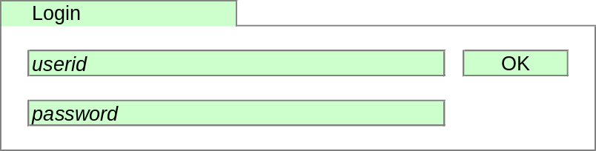

Workbook Types
CRST is organised as a number of workbooks, each designed to achieve a particular purpose.

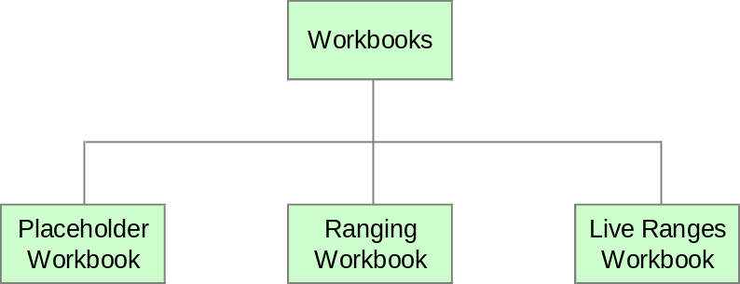

- The Placeholder Workbook is used to set-up and maintain placeholder products and to link placeholder products to CW products.
- The Ranging Workbook is used to perform range changes.
- The Live Ranges Workbook is used to view the current live range for any Merchandising Group. In addition the workbook can be used to view any authorised ranges not yet live (i.e. a range has been authorised but has not yet reached its effective date).

Choosing the Workbook To Create

Sample Screen
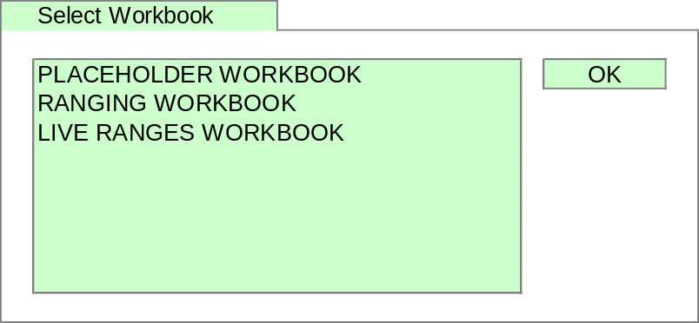

Placeholder Workbook

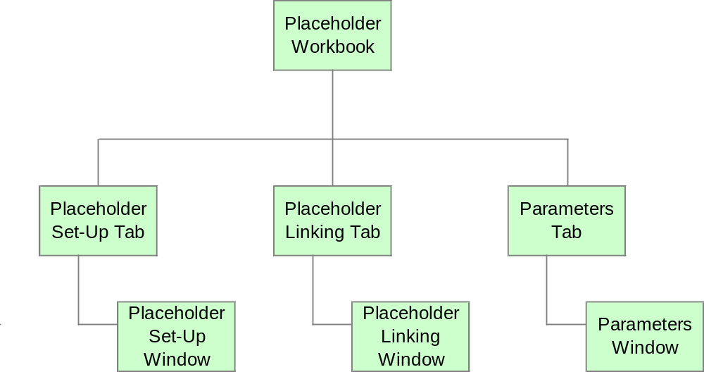

The Placeholder Workbook is organised as a number of tabs, which are designed to lead the Commercial user through the placeholder process.
- The Placeholder Set-Up Tab contains one window:
- The Placeholder Set-Up Window is used to enter descriptions for each placeholder to be used in ranging.
- The Placeholder Linking Tab contains one window:
- The Placeholder Linking Window is used to link placeholders to TPNBs from CW.
- The Parameters Tab contains one window:
- The Parameters Window is used to set the number of unused placeholders to be available for each Sub Group

Workbook Build Wizard

Process Flow
The workbook build wizard will guide the user through the following process


Sample Screen
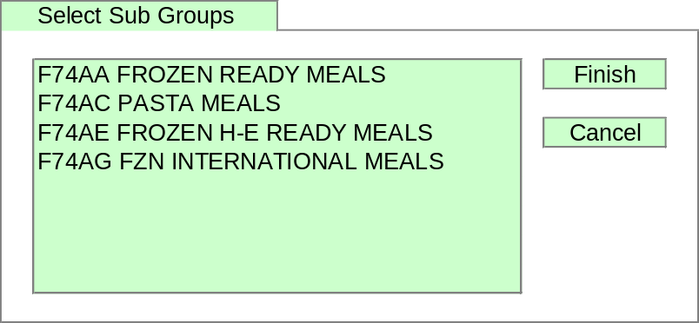

Placeholder Set-Up Window
The Placeholder Set-Up Window is used to enter descriptions for any placeholders to be used in ranging.

Sample Screen
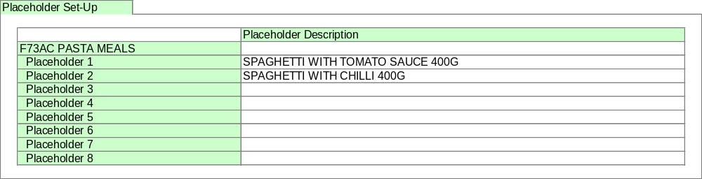

Placeholder Linking Window
The Placeholder Linking Window is used to link placeholder products to TPNBs in CW.

Sample Screen
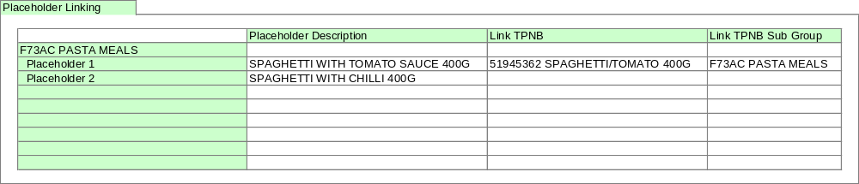

Parameters Window
The Parameters Window is used to override the number of unused placeholders per Sub Group. The default for each Sub Group will be 50.

Sample Screen
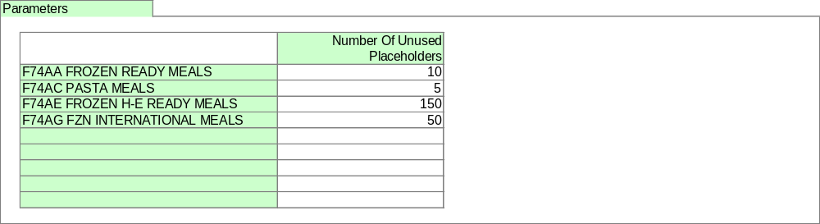

Ranging Workbook

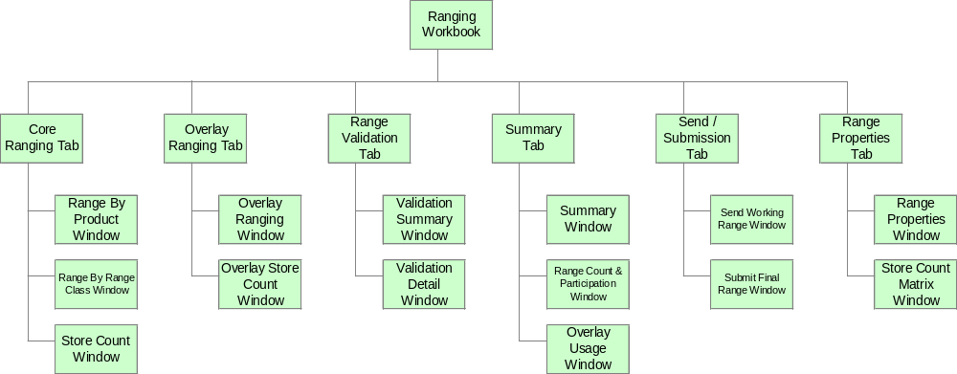

The Ranging workbook is organised as a number of tabs, which are designed to lead the Commercial user through the ranging process.
- The Core Ranging Tab contains three windows:
- The Range By Product Window, which is used to make core range changes for each Store Cluster and Range Class using a TPNB centric viewpoint (i.e. shows how a TPNB is ranged across all Range Classes).
- The Range By Range Class Window, which is used to make core range changes for each Store Cluster and Range Class using a Range Class centric viewpoint (i.e. shows how TPNBs are ranged within a specific Range Class).
- The Store Count Window, which shows information about the number of stores allocated to each Range Class within a Store Cluster. This window is linked to the ranging windows so that it always shows information for the Store Cluster currently being ranged.
- The Overlay Ranging Tab contains two windows:
- The Overlay Ranging Window, which is used to specify TPNBs to overlay the core range for each Store Cluster and Range Class.
- The Overlay Store count Window shows the number of stores in Range Class within each Store Cluster for each overlay type.
- The Validation Tab contains two windows:
- The Validation Summary Window, which shows the number of errors in each Store Cluster.
- The Validation Detail Window, which shows details of any errors or warnings identified when the system checks the ranges.
- The Summary Tab contains three windows:
- The Summary Window, which shows the lowest Range Class for each product in each Store Cluster, both As Is and To Be, and the number of stores the product will be ranged in
- The Range Count & Participation Window, which shows the number of products in the range for each Store Cluster, both As Is and To Be, the number of deleted products, the number of changes made and the number of lines used as Overlays
- The Overlay Usage Window, which shows a list of Overlay lines and their victim lines for each Store Cluster.
- The Send / Submission Tab contains two windows:
- The Send Working Range Window, which can be used to send ranges that are still under construction to Merchandising
- The Submit Final Range Window, which is used to submit the final ranges to Merchandising.
- The Range Properties Tab contains two windows:
- The Range Properties Window, which shows general information about the ranges in the ranging workbook, such as the type of range change, e.g. Refresh, the effective dates for the range changes and the Sales History period used.
- The Store Count Matrix Window, which shows store count by Range Class within each Store Cluster and a total for all Store Clusters.

Workbook Build Wizard

Process Flow
The workbook build wizard will guide the user through the following process

Sample Screens
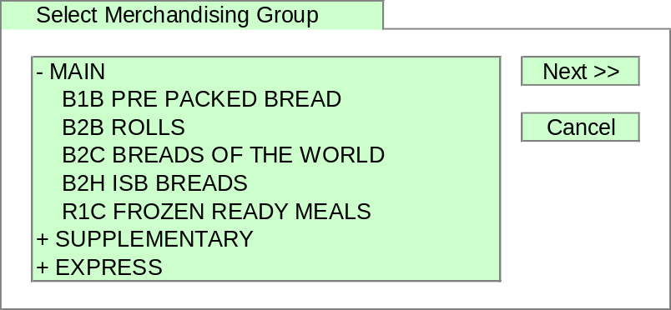

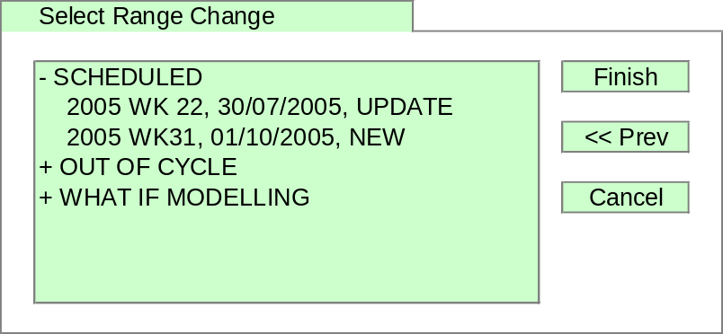

Core Ranging Tab

Range By Product Window
The Range By Product Window is which is used to make core range changes for each Store Cluster and Range Class using a TPNB centric viewpoint (i.e. shows how a TPNB is ranged across all Range Classes).

Sample Screen

Default Screen
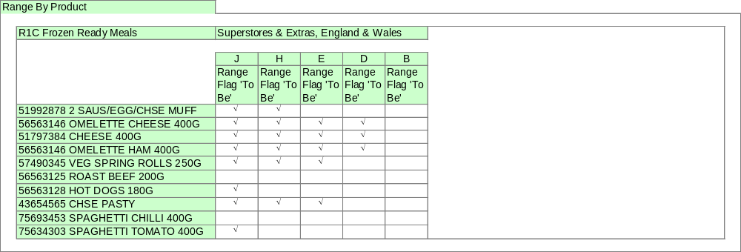

Screen With More Measures (Selected Using A Menu Option)
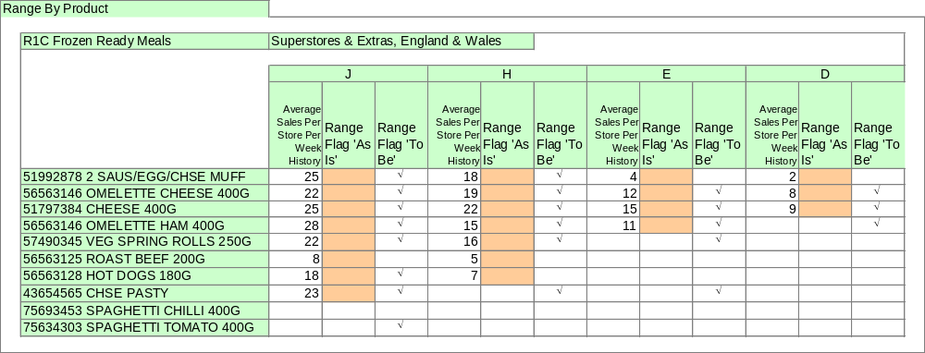

Range By Range Class Window
The Range By Range Class Window can be used for two purposes.
First the window can be used to make core range changes for each Store Cluster and Range Class using a Range Class centric viewpoint (i.e. shows how TPNBs are ranged within a specific Range Class).
Second Range Class can be turned off to give a Store Cluster view of the range including highest and lowest Range Class, Sales History and Sales ‘To Be’ for each TPNB.

Sample Screen

Default Screen
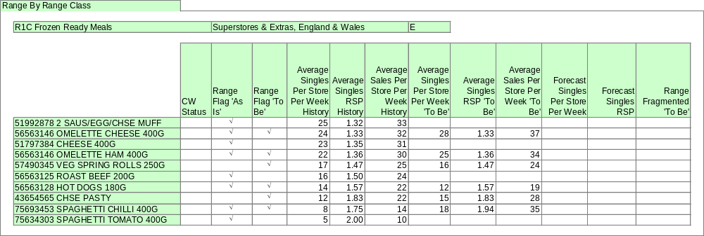

Screen Without Range Class Using Different Measures (Selected Using A Menu Option)
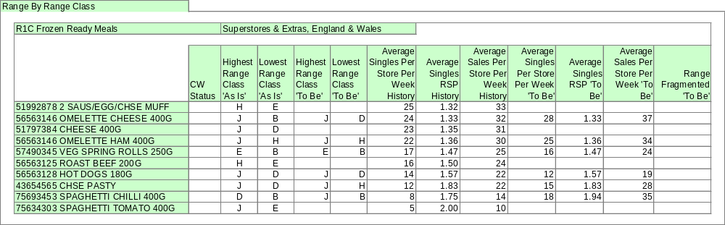

Store Count Window
The Store Count Window shows a number of pieces of information about each Range Class within the Store Cluster currently being ranged. A user will use this window to obtain information about the number of Stores across the Range Classes within each Store Cluster to assist in making ranging decisions. The window is positioned permanently below the ranging window and shows information about the cluster currently being ranged.

Sample Screen
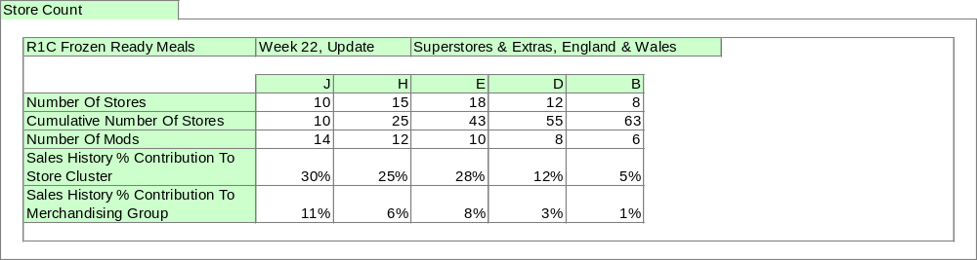

Overlay Ranging Tab

Overlay Ranging Window
The Overlay Ranging Window is used to specify products to be overlaid on the core range for each Store Cluster for each Overlay Type specified in Pre-Ranging.

Sample Screen
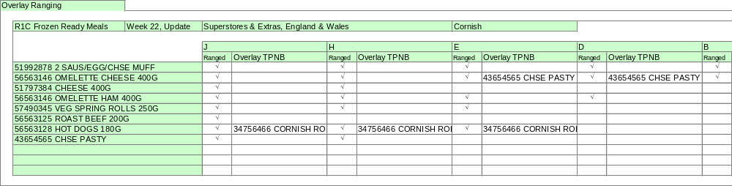

Overlay Store Count Window
The Overlay Store Count Window shows the number of stores for each Range Class within the Store Cluster currently being ranged for each overlay type. The window is positioned permanently below the ranging window and shows information about the cluster currently being ranged. (This is a deliverable for February.)

Sample Screen
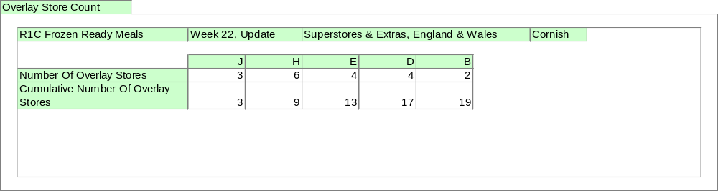

Range Validation Tab

Validation Summary Window
The Validation Summary Window shows the numbers of errors or warnings for the range for each Store Cluster.

Sample Screen
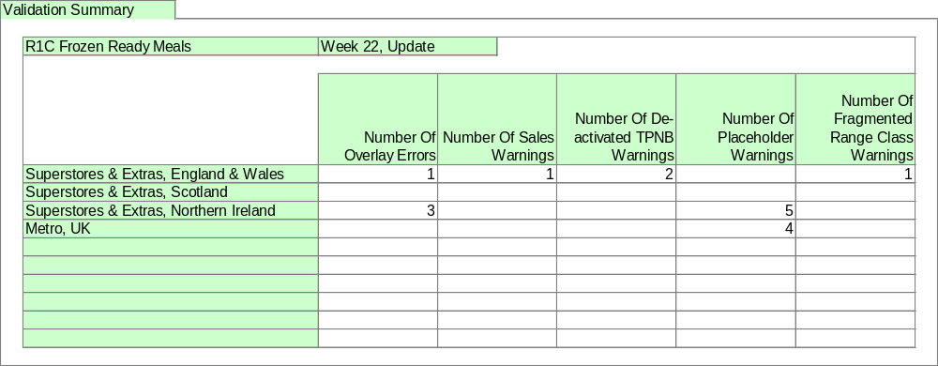

Validation Detail Window
The Validation Detail Window shows any errors in the range or any warnings for the range. Only TPNBs that have errors will be displayed. The user will use this screen to ensure the range has no errors that will stop submission to Merchandising. In addition there may be warnings about a range that will not stop a range being submitted but about which the user should be aware.

Sample Screen
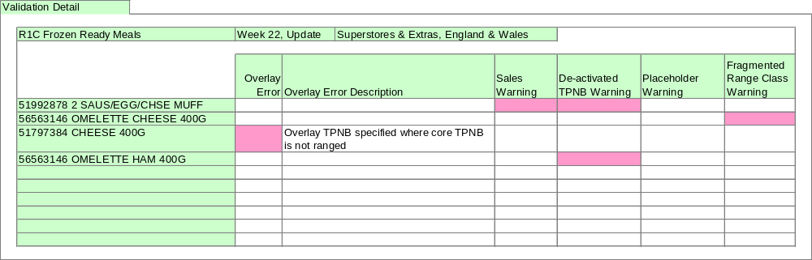

Summary Tab

Summary Window
The Summary Window displays information about the number of stores for each TPNB across its Store Clusters.

Sample Screen
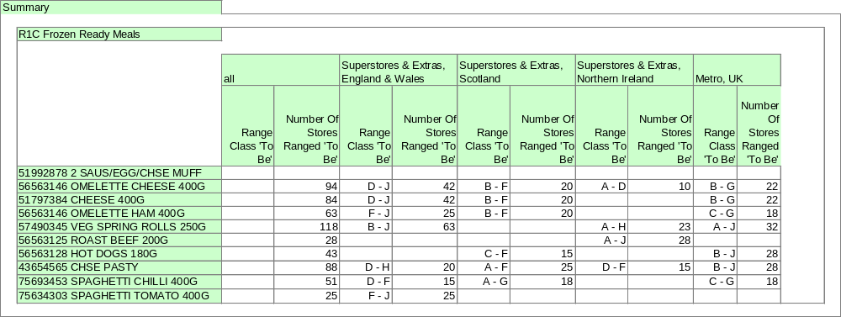

Range Count Window
The Range Count Window gives summary information of the number of products in a range, new product count, deleted product count, etc used within a Store Cluster.

Sample Screen
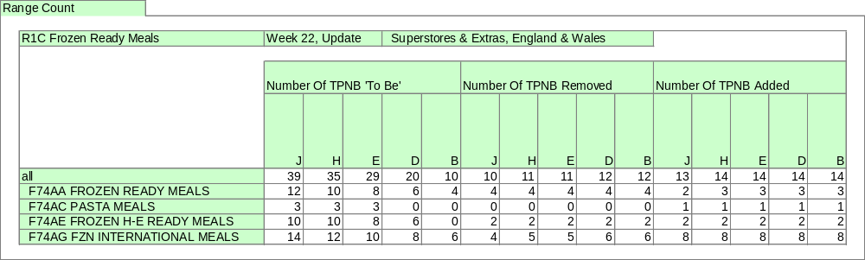

Overlay Usage Window
The Overlay Usage Window shows the list of products used as overlays within a Store Cluster. No screen design is available yet.

Send/Submission Tab

Send Working Range Window
The Send Working Ranges Window is used to send ranges to Merchandising so that a range can be modelled in Pro-Space at an early stage in the range change cycle, for example before visiting the Merchandising Centre. Typically this will be used only for major range updates and usually only for the largest Range Class.
Sending a range does not indicate that the range has been completed in any way, it is still considered to be work in progress. The Submit Final Range Window is used to send the completed range from CRST to Merchandising.

Sample Screen
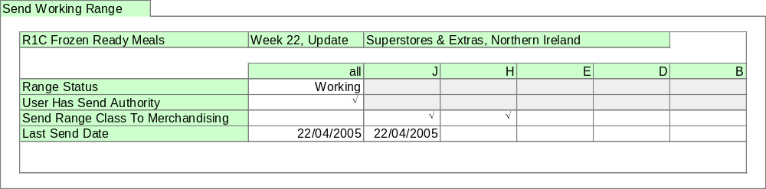

Submit Final Range Window
The Submit Final Range Window is used to send the completed range from CRST to Merchandising for each Store Cluster. When a Store Cluster is submitted it is locked within CRST to prevent any further changes.
In addition the window can be used to unlock Store Clusters previously submitted to Merchandising and as a result locked in CRST. This is to support the re-planning of a Store Cluster rejected by Merchandising.

Sample Screen
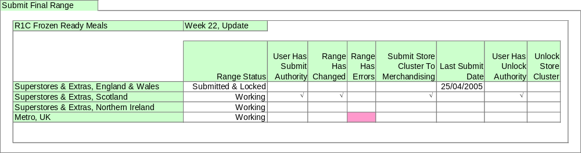

Range Properties Tab

Range Properties Window
The Range Properties Window shows general information about the Range Change.

Sample Screen
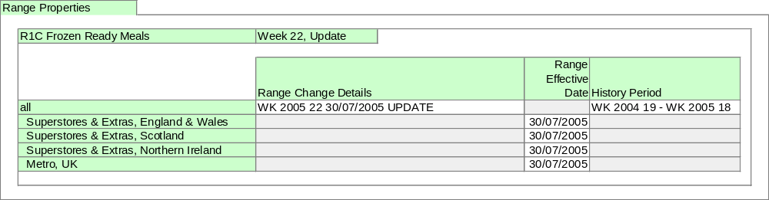

Store Count Matrix Window
The Store Count Matrix Window shows the store count by Store Cluster and Range Class. A user will use this window to obtain information about the number of Stores across all Range Classes and Store Clusters within the Range Change.

Sample Screen
